**Neural Network with GPU**

1. **Create your first Jupyter Notebook**
2. Navigate to [http://drive.google.com](http://drive.google.com./) and Login to your drive.
3. You will see **My Drive** tab on the left pane. Now, create a folder inside it, say **Colab Notebooks**.
4. Right click somewhere else on the right pane inside the created folder, select**More**>**Colaboratory**. Another window will pop-up and you can name your notebook to something else, say **myNotebook.ipynb**.
5. **Set a GPU accelerator for the notebook**

In the notebook, select **Runtime** > **Change runtime type**. One window will pop up. Then, choose your runtime type, select **GPU** from Hardware accelerator dropdown menu and save your settings (Figure below).

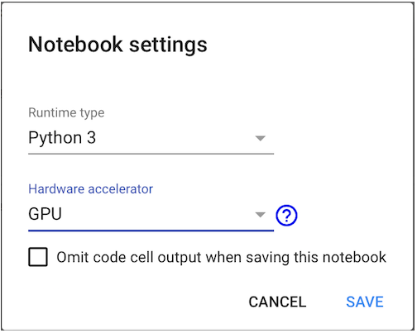

1. **Upload your custom datasets to Colab**

You have finished setting up your notebook to run on a GPU. Now, let’s upload your datasets to Colab. In this tutorial, we work on [Foreground Segmentation](https://en.wikipedia.org/wiki/Foreground_detection), where foreground objects are extracted from the background (Figure below).

There are several options in uploading datasets to Colab, however, we consider two options in this tutorial; first, we upload to GitHub and clone from it to Colab, second, we upload to Google Drive and use it directly in our notebook. You may choose either option **a).** or **b).** below:

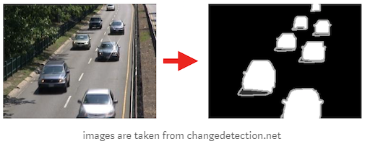

#### Clone from GitHub

Let’s clone above dataset to the created notebook. In your notebook’s cell, run:

!git clone <https://github.com/lim-eren/CDnet2014.git>.

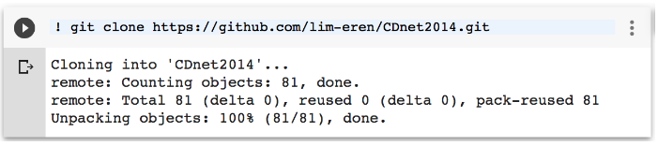

Done! Let’s list down the training set to see if it works:

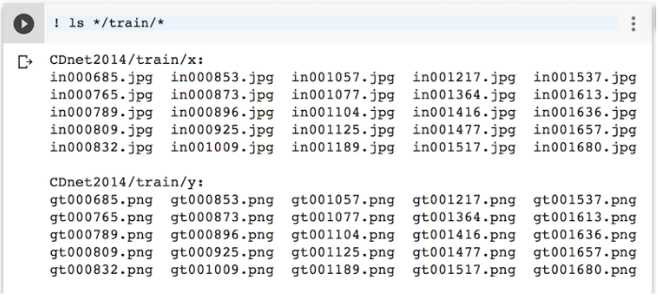

#### Download from Google Drive

Another option is to upload your dataset to Google Drive and clone from it. Suppose that you have already zipped the training set above, say **CDnet2014.zip**, and uploaded to Google Drive in the same directory as **myNotebook.ipynb**. Now, right click on **CDnet2014net.zip** > **Get shareable link**. Copy file’s **id** and store it somewhere (we will use it later).

Then, authenticate Colab to access Google Drive by running the following codes. Follow the link to get a verification code and paste it in below textbox, then press Enter.

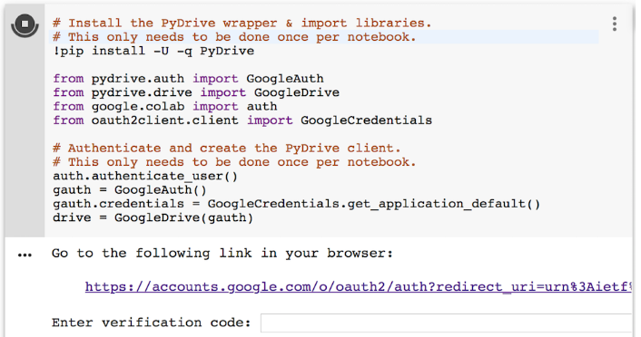

Then, let’s download **CDnet2014net.zip** file content into our Jupyter Notebook (replace YOUR\_FILE\_ID with the **id** obtained in above step) and unzip it by running the following codes:

Done! You have downloaded your dataset from Google Drive to Colab. Let’s proceed to **section 4** to build a simple neural network using this dataset.

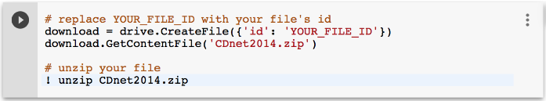

1. **Fine-tune your neural network**

After your dataset is downloaded to Colab, now let’s fine-tune Keras pre-trained model in Foreground Segmentation domain. Please follow the following steps:

1. First of all, add this code snippet on top of your notebook to obtain reproducible results across machines (please run the code snippets in your notebook’s cells):

|  |
| --- |
| # Run it to obtain reproducible results across machines (from keras.io)  from \_\_future\_\_ import print\_function  import numpy as np  import tensorflow as tf  import random as rn  import os  os.environ['PYTHONHASHSEED'] = '0'  np.random.seed(42)  rn.seed(12345)  session\_conf = tf.ConfigProto(intra\_op\_parallelism\_threads=1, inter\_op\_parallelism\_threads=1)  from keras import backend as K  tf.set\_random\_seed(1234)  sess = tf.Session(graph=tf.get\_default\_graph(), config=session\_conf)  K.set\_session(sess) |

1. Create a function to load data from Colab. This function returns input images (X) with corresponding ground-truths (Y):

|  |
| --- |
| # load data func  import glob  from keras.preprocessing import image as kImage  def getData(dataset\_dir):  X\_list= sorted(glob.glob(os.path.join(dataset\_dir, 'x','\*.jpg')))  Y\_list = sorted(glob.glob(os.path.join(dataset\_dir, 'y' ,'\*.png')))    X= []  Y= []  for i in range(len(X\_list)):  # Load input image  x = kImage.load\_img(X\_list[i])  x = kImage.img\_to\_array(x)  X.append(x)    # Load ground-truth label and encode it to label 0 and 1  x = kImage.load\_img(Y\_list[i], grayscale = True)  x = kImage.img\_to\_array(x)  x /= 255.0  x = np.floor(x)  Y.append(x)  X = np.asarray(X)  Y = np.asarray(Y)    # Shuffle the training data  idx = list(range(X.shape[0]))  np.random.shuffle(idx)  X = X[idx]  Y = Y[idx]  return X, Y |

1. Initial a vanilla encoder-decoder model. We adapt the [VGG-16 pre-trained model](https://github.com/keras-team/keras-applications/blob/master/keras_applications/vgg16.py) as an encoder, where all fully-connected layers are removed, only the last convolutional layer (block5\_conv3) is fine-tuned and rest of the layers are frozen. We use transposed convolutional layers to recover features resolution in the decoder part.

Since it is a binary classification problem, binary\_crossentropy is used and the output from the network will be the probability values between 0 and 1. These probability values need to be thresholded in order to obtain binary label 0 or 1, where label 0 represents the background and label 1 represents the foreground.

|  |
| --- |
| import keras  from keras.models import Model  from keras.layers.convolutional import Deconv2D  from keras.layers import Input  def initModel():  ### Encoder  net\_input = Input(shape=(240,320,3))  vgg16 = keras.applications.vgg16.VGG16(include\_top=False, weights='imagenet', input\_tensor=net\_input)  for layer in vgg16.layers[:17]:  layer.trainable = False    x = vgg16.layers[-2].output # 2nd layer from the last, block5\_conv3    ### Decoder  x = Deconv2D(256, (3,3), strides=(2,2), activation='relu', padding='same')(x)  x = Deconv2D(128, (3,3), strides=(2,2), activation='relu', padding='same')(x)  x = Deconv2D(64, (3,3), strides=(2,2), activation='relu', padding='same')(x)  x = Deconv2D(32, (3,3), strides=(2,2), activation='relu', padding='same')(x)  x = Deconv2D(1, (1,1), activation='sigmoid', padding='same')(x)    model = Model(inputs=vgg16.input, outputs=x)  model.compile(loss=keras.losses.binary\_crossentropy, optimizer=keras.optimizers.RMSprop(lr=5e-4), metrics=['accuracy'])  return model |

1. We set a learning rate of 5e-4, batch\_size of 1, validation\_split of 0.2, max-epochs of 100, reduce the learning rate by a factor of 10 when validation loss stops improving in 5 epochs, and stop the training early when validation loss stops improving in 10 epochs. Now, let’s train the model.

|  |
| --- |
| # load data  dataset\_path = os.path.join('CDnet2014', 'train')  X, Y = getData(dataset\_path)  # init the model  model = initModel()  early = keras.callbacks.EarlyStopping(monitor='val\_loss', min\_delta=1e-4, patience=10)  reduce = keras.callbacks.ReduceLROnPlateau(monitor='val\_loss', factor=0.1, patience=5)  model.fit(X, Y, batch\_size=1, epochs=100, verbose=2, validation\_split=0.2, callbacks=[reduce, early], shuffle=True)  model.save('my\_model.h5') |

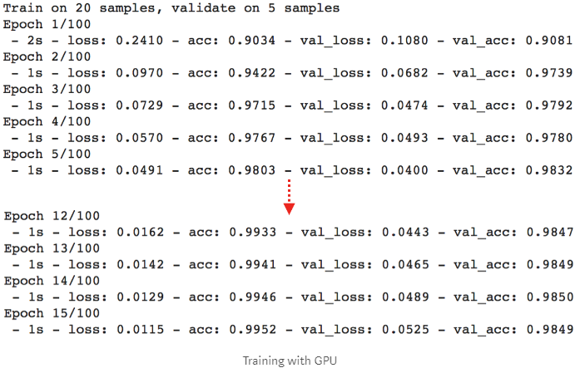

It takes around **1 second for one epoch**, so fast!!! The maximum accuracy is above 98% on validation set. Not bad, right? Now, let’s pause a bit. Let’s compare the speed between training **with and without GPU** (you can skip this comparison and jump to testing part if you want). To train without GPU, set **Hardware accelerator** to **None** (refer to Section 2. above). Here is the training logs. Without GPU, it takes around **30 seconds for one epoch,**while it takes only **1 second** when training with GPU (about 30x faster).

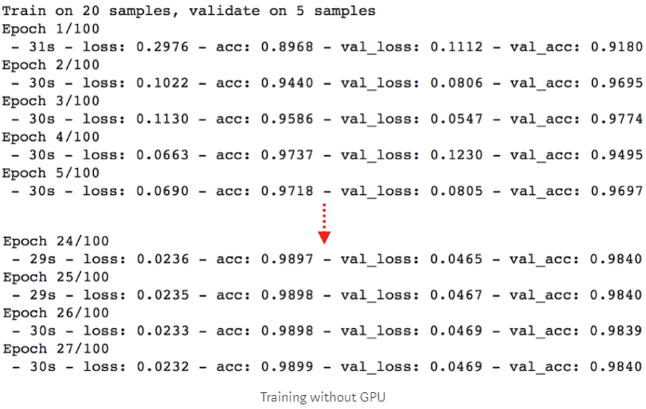

Now, let’s test the trained model on **test set** with Colab GPU (you can run !ls \*/test/\* to see testing frames with corresponding ground-truths).

|  |
| --- |
| # load test data  dataset\_path = os.path.join('CDnet2014', 'test')  X, Y = getData(dataset\_path)  # predict  pred = model.predict(X, verbose=1, batch\_size=1)  print(tf.Session().run(K.mean(K.equal(Y, K.round(pred)))))  # output: test on GPU  # 10/10 [==============================] - 1s 68ms/step  # 0.98944664 |

We can achieve **98.94%** testing accuracy by just using 25 training+validation examples with a vanilla network. Note that due to the randomness of training examples, you may get similar results as mine (not exactly the same but only a small precision difference).

**Note one issue**: Our model is overfitting the training data, this is your job to combat this problem. **Hint**: Use regularization techniques likes [Dropout](https://keras.io/layers/core/#dropout), [L2](https://keras.io/regularizers/), [BatchNormalization](https://keras.io/layers/normalization/" \t "_blank) .

1. Let’s plot the segmentation mask by running the following codes:

|  |
| --- |
| import matplotlib.pyplot as plt  plt.rcParams['figure.figsize'] = (12.0, 9.0)  idx = 1 # image index that you want to display  img = np.empty(3, dtype=object)  img[0] = X[idx]  img[1] = Y[idx].reshape(Y[idx].shape[0],Y[idx].shape[1])  img[2] = pred[idx].reshape(pred[idx].shape[0],pred[idx].shape[1])  title = ['input', 'ground-truth', 'result']  for i in range(3):  plt.subplot(1, 3, i+1)  if i==0:  plt.imshow(img[i].astype('uint8'))  else:  plt.imshow(img[i], cmap='gray')    plt.axis('off')  plt.title(title[i])  plt.show() |

Here we go! The segmentation result is not bad at all! Most of the object boundaries are misclassified and this problem primarily due to the case where void labels (ambiguous pixels around the object boundaries) are considered in the loss computation during training. We can improve the performance more by omitting these void labels in the loss.

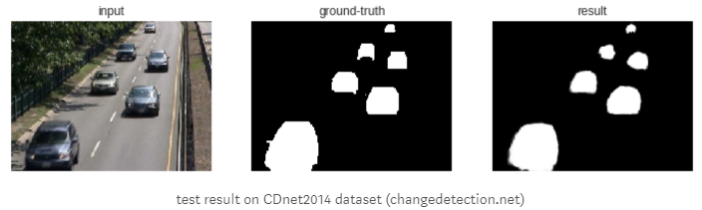

**Repeat the experiment with CPU configuration**

Source: https://towardsdatascience.com/a-comprehensive-guide-on-how-to-fine-tune-deep-neural-networks-using-keras-on-google-colab-free-daaaa0aced8f